Curriculum Vitae
______________________________________________________

First: - Personal Information
Name: Falah Hasan Hanoon ALasady
Birth:1974 Thi-Qar
University: Thi-Qar
College: Science
Department: Physics
Degree: Ph.D.
Title: Prof.
Mobile: 07804530307
Email: drfh24@yahoo.com and falah.hasan_phy@sci.utq.edu.iq
Second: Qualifications
Specialization | Country | University | year | Degree
Physics | Iraq | Basrah | 1995-1996 | Bachelor
Laser physics | Iraq | Basra | 1998 | Master
Solid state physics | Iraq | Basra | 2008 | Doctorate of Philosophy

Third: Employment Record
- Reporter of Postgraduate in department of physics.
- Member of the exam committee
- Teaching in the Department of Physics
- Supervising the students of the fourth stage
- Supervising Postgraduate students
Fourth: Conference
- 1st Faculty of Science Conference for the year 2015
- The 2nd Scientific Conference of the College of Science 2019
- The 5th International scientific Conference on Nanotechnology& Advanced Materials Their Applications
- Workshop in Qatar university electronic microscope SEM and STM and nanostructure 2015
- Workshop in Sulaimaniah university for XRD and XRF 2016

البحوث المنشورة
Title | Year | Journal
Investigation of the electronic structure for rhenium Oxide Tetra Chloride by B3lyp Density functional Theory | 2013 | Journal of university of babylon | 1
Structural and electronic properties of Donor – Acceptor molecule system | 2014 | JOURNAL OF THI-QAR SCIENCE | 2
Calculation of vibrational life time of single adsorbate on metal surface with STM | 2014 | JOURNAL OF THI-QAR SCIENCE | 3
Density functional theory investigation for Sodium atom on Copper cluster | 2015 | IJSR | 4
Density Functional Theory Investigation for H^ sub 2^-Silver Interactions‏ | 2015 | International Journal of Pure and Applied Sciences and Technology | 5
Wave Packet Propagation and Density Functional Theory Investigation For Na-AgCu Interactions‏ | 2015 | International Journal | 6
Geometrical optimization and some physical properties for sodium on copper cluster | 2015 | Journal of applied physics (IOSR) | 7
Geometrical optimization and electronic properties of Li on Xn Nanocluster | 2017 | International journal of new Technology | 8
Metastable He * Atom -3ML Ag /Cu(111)surface Interaction by using wave packet propagation method | 2017 | International Journal of science research | 9
Theoretical study of electron transport through some molecular structurs | 2017 | Superlattices and microstructure | 10
The electronic properties of concentric double quantum ring and possibility designing XOR gate | 2017 | Solid State Communications | 11
Effect of thickness on the fractal optical modulator for MgF2, LiF, AL2O3 materials by testing modulation transfer function (MTF) | 2017 | Journal of Education for Pure Science | 12
Theoretical study of electron transport throughout some  molecular structures | 2017 | Superlattices and Microstructures | 13
Possibility designing XNOR and NAND molecular logic gates by using single benzene ring | 2017‏ | Solid State Communications | 14
Possibility designing half-wave and full-wave molecular rectifiers by using single benzene molecule | 2018 | Physics Letters A | 15
Electronic structure and band gap engineering of bilayer graphene nanoflaks in the presence of nitrogen boron and boron nitrogen impurities | 2018 | Solid state comunication | 16
A theoretical Design of a new organic dye containing coronene for Dye sensitize solar cells | 2018 | Journal of thin film research | 17
Semi-metallic bilayer MS2 (M= W, Mo) induced by Boron, Carbon, and Nitrogen impurities‏ | 2018 | Solid State Communications | 18
Theoretical study of electronic properties for pristine and  alloyed double metal rings | 2019 | IOP Conf. Series: Journal of Physics | 19
Chinese Journal of Physics | 2019 |  | 20
Electronic structure and band gap engineering of bilayer graphene nanoflakes in the presence of nitrogen, boron and boron nitride impurities‏ | 2019 | Superlattices and Microstructures | 21
Study of structural, optical and sensitivity properties of NiPc thin film prepared by thermal evaporation‏ | 2020 | AIP Conference Proceedings | 22
Using of cellulose with various nanoparticles as chelating factors in nanovaccines: Density functional theory investigations‏ | 2020 | Solid State Communications | 23
Adaptive prism using a double quantum dot structure‏ | 2020 | Applied Optics | 24
Enhancement the physicochemical properties of ZnONS in the presence various concentrations of Ga impurities and difference anticancer drug molecules | 2020 | Physica E: Low-dimensional Systems and Nanostructures | 25
Investigation the structural and optical properties of Nickel phthalocyanine (NiPc)thin films prepared by chemical spray pyrolysis method | 2020 | Journal of Physics conference series | 26

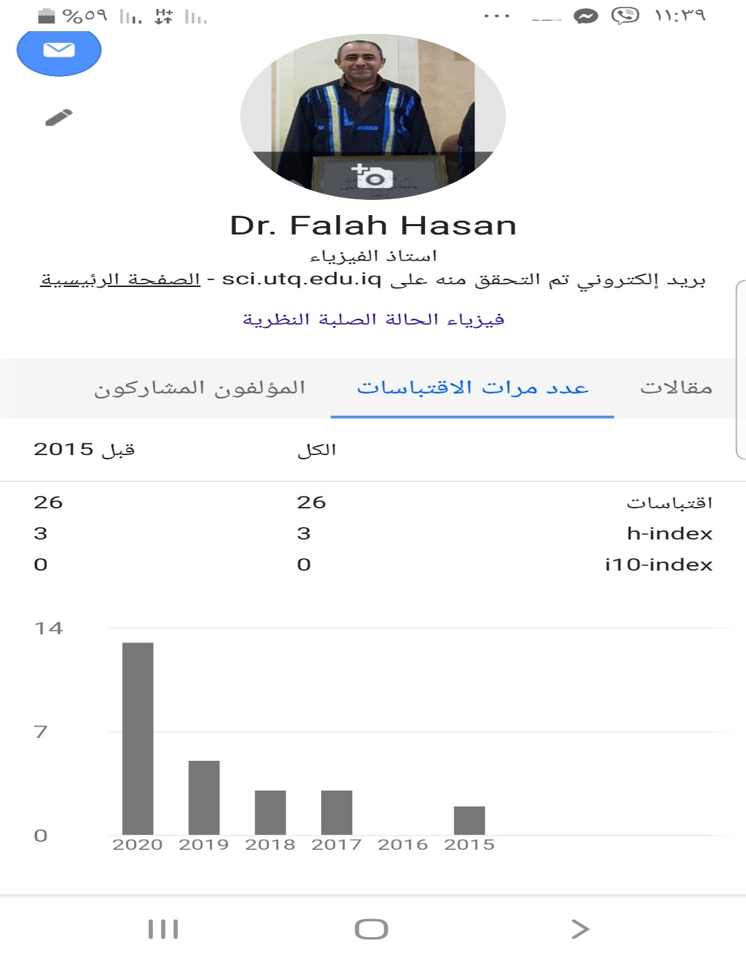

Research number diagram from 2015 until 2020

Sixth: Supervising postgraduate students: 5 PhD and 9 MSc

Seventh: Tasks

1-Head of Physics assistance from 2000-2003
2-Head of physics from 2003-2006
3-Head of physics and computer departments 2009-20014
4-Head of computer engineering department 2009-2011

